POTTERY HUB

Student ID: 3455375
Main HTML file: home.html

UX-DESIGN ASSIGNMENT REPORT

1. Concept and Target Users
Pottery hub website is an interactive website that is devoted for pottery lovers of all levels. The core concept of this website is to provide an interactive space and a space to learn about pottery traditions with upcoming workshops and video tutorials. The main highlight of this website is its Gallery page where the users can upload their work and view other’s work making it a distinctive site. The main purpose of this site is to preserve the ancient cultures by providing information about them and to promote the richness of pottery making.
This is a strong design concept because it combines both indigenous education and modern pottery techniques through user-friendly interfaces. Unlike many existing pottery-related websites that mainly focuses on selling products, Pottery Hub focuses on cultural learning and community engagement. It aims to preserve the artistic heritage of pottery while also introducing modern design practices that appeal to today’s generation. The website creates a calm, earthy, and welcoming digital space. It helps users to get connected to artistic world rather than a dark life.
The target users are primarily beginners who are curious to start learning pottery and experienced pottery artists who loves to explore new techniques or connect with like-minded individuals. This website is suitable for users aged between 15-40 years, particularly those interested in art, culture, creative activities. By catering to a diverse range of users, Pottery Hub becomes not just a learning platform but also a creative community.

1.1 User Persona
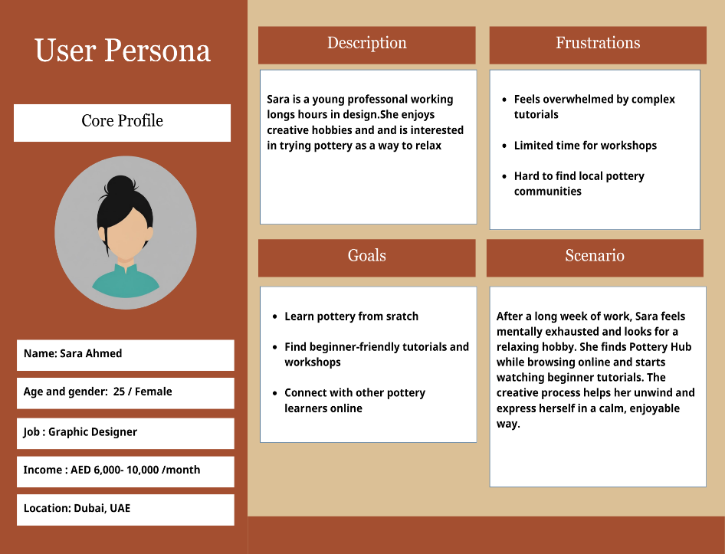
Fig 1.1 User Persona of a Graphic Designer [5]

The user persona above represents Sara Ahmed, a 25-year-old Graphic Designer from Dubai who seeks balance between her hectic schedule and personal well-being. She works in a tight schedule. She enjoys creative activities and view pottery as a relaxing way to express herself after long working hours.
Sara’s main goals are learn pottery from scratch, find beginner-friendly tutorials and workshops, and connect with other pottery learners. Her frustrations are overwhelmed by complex tutorials, limited time for offline workshops, hard to find local pottery communities. This persona helps identify the needs and motivations of Pottery Hub’s target audience, guiding the website’s design and content strategy.
Scenario: After an exhausting week at work, Sara feels mentally exhausted and looks for a relaxing hobby. While browsing online, she finds Pottery Hub. Pottery Hub, an interactive platform offering tutorials and workshops for beginners. She explores beginner videos, learns basic pottery techniques and interacts with other learners. The calm and creative nature of the platform allows her to relax, relieve stress and gain a sense of accomplishment.
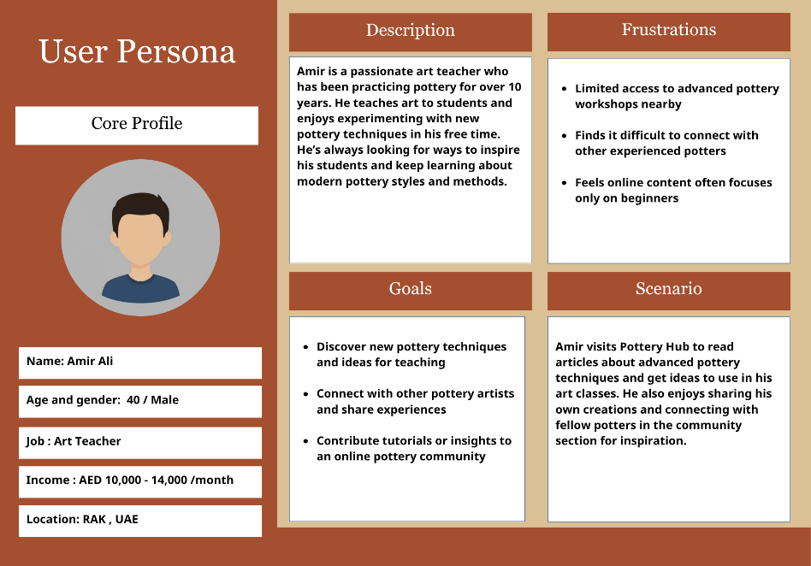
Fig 1.2 User Persona of an Art Teacher [5]
The above user persona represents Amir Ali, a 40-year-old from Ras Al Khaimah who has been passionate Art Teacher for over 10 years. He is well experienced in pottery making field. With extensive experience in both teaching and practicing art Amir incorporates pottery into his lessons to inspire creativity among students.
Amir’s main Goals are to discover new pottery techniques and ideas for teaching, contact with other pottery artists and share experiences, contribute tutorials or insights to an online pottery community. His frustrations are limited access to advances pottery workshops nearby, finds it difficult to connect with other potters, feels online contents focuses only on beginners.
Scenario: Amir visits pottery hub to read articles about advanced pottery techniques and get ideas to use in his art classes. The community Gallery also allows him to showcase his own work. Amir finds a supportive platform that keeps him inspired, connected, and continuously growing as both an artist and educator.

2. Design Development
The initial idea of Pottery Hub began with the concept of artistic encouragement and traditional attachment. From this idea it was expanded to a complete design featuring five pages that displays the sole purpose of the website and with perfect layout consistency. The design was developed using W3.CSS for a responsive layout, combined with HTML, CSS and Java script for visual styling and user-friendly browsing experience.
The website was structured into five main pages- Home, About, Traditions, Gallery, and Workshop, along with a Sign In form. Each page was designed carefully to maintain layout consistency, visual harmony, and user-friendly navigation. The overall design follows a clean structure with clear visual hierarchy, ensuring that users can intuitively explore all sections without confusion.
The color palette of natural clay tones conveys a feeling of coziness and artistry, drawing inspiration from the textures of clay and terracotta. Serif title and sans-serif body texts were balanced through the selection of fonts based on readability and harmony. Another important factor was accessibility, which is ensured by mobile-friendly font sizes, descriptive texts, and high contrast colors on all devices.
The Home page displays a welcoming point for the users to dive in to the website. It has a background image to display the theme of pottery along with the title ‘pottery hub’ and a tagline. It has quick links to other pages in the navigation bar and a call-to-action encouraging users to explore through the main pages which enhances the user interface of the website along with a footer which is common for all pages.
The About page is a Heritage Hub which displays the description of the site, the mission and the features of the website. This page provides a clear idea of the site to the users.
The Traditions page is a Knowledge Hub as it involves many information about pottery. It starts with comparing pottery traditions in UAE and Japan. It includes ancient techniques of pottery like the ancestral living art and the ceremonial pottery. This page also have a pottery timeline describing pottery styles in different era.
The Gallery page is an interactive hub and the main attraction of the site. This page allows users to upload their finished works and view other’s work. It also have a filter bar to categorize each type of pottery combined with a search by title bar.
The Workshop page includes all the upcoming workshops and video tutorials. The signed in users can join the upcoming free workshops by providing their credentials. The users can also watch the embedded YouTube video tutorials for different levels including Beginner to Experienced.
The Sign In form allows users to register for the upcoming free workshops and for new updates. It includes a simple and accessible form layout with boxes asking for email and password and a sign in button.
In summary, the design development process of Pottery Hub focused on creating a harmonious balance between functionality, aesthetics, and cultural appreciation. Every page, color element was chosen thoughtfully to provide users with as engaging, informative, and visually soothing experience.

2.1 Sitemap

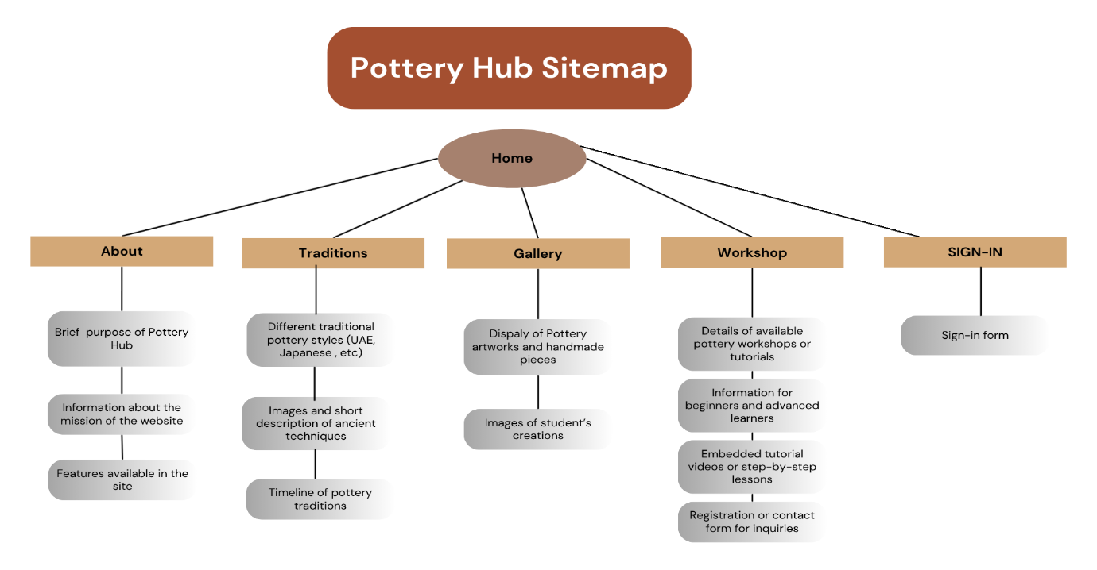
Fig 2.1.1 Sitemap [4]

The structure of sitemap connects all the pages, with the home page serving as the central hub for the entire website. Navigation links are consistently displayed across every page, ensuring smooth transitions and easy movements between sections. The overall site sequence follows a logical sequence, beginning from Home page as the central hub followed by about page which acts as heritage hub describing the purpose and the vision of the website. The Tradition page functions as a knowledge hub were the users can learn about pottery styles and cultural practices, while the Galley serves as an interactive Hub showcasing creative works. Finally, the Workshop page represents the Creation Hub of the site, encouraging participation through learning and practice.
This design effectively satisfies the needs of both personas. Sara benefits from calm visually balanced interface and the beginner-friendly content layout, while Amir gains value from exploring modern pottery techniques and engaging with the community gallery where he can share his creations and view others’ work. The use of responsive layouts adheres to accessibility guidelines, making the site fully functional and visually consistent across mobile devices, tablets and desktops.

2.2 Wireframe
The wireframe illustrates the raw structure and layout of the Pottery Hub website, showing how content and navigation elements are organizes before the design stage.

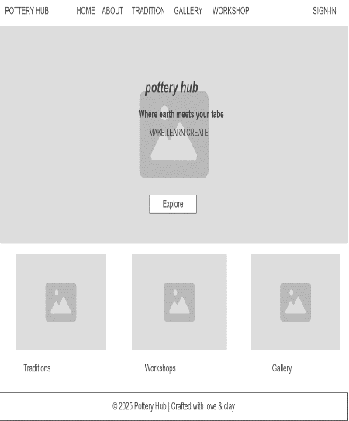
Fig 2.2.1 Page 1 [4]
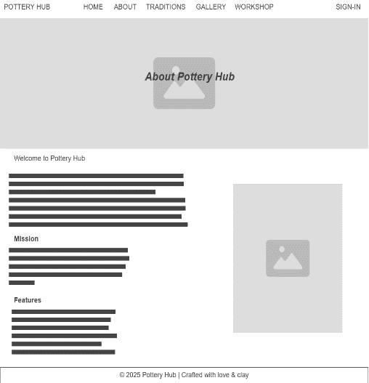
Fig 2.2.2 Page 2 [4]

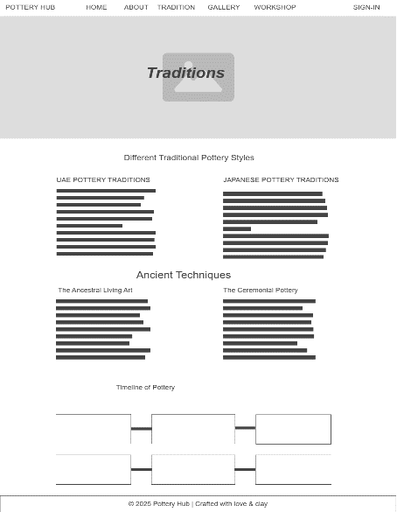
Fig 2.2.3 Page 3 [4]
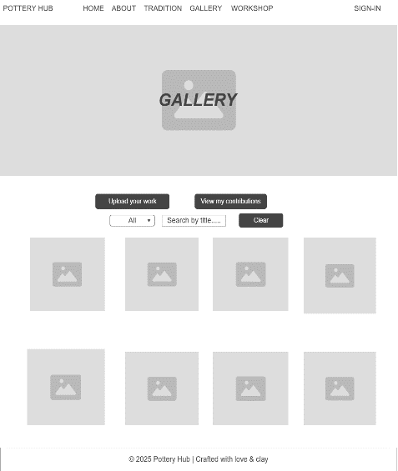
Fig 2.2.4 Page 4 [4]

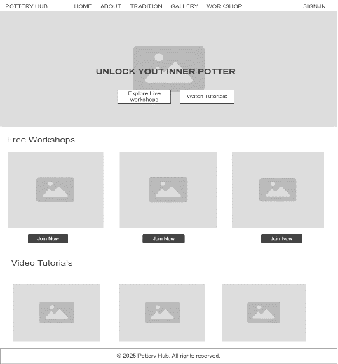
Fig 2.2.5 Page 5 [4]
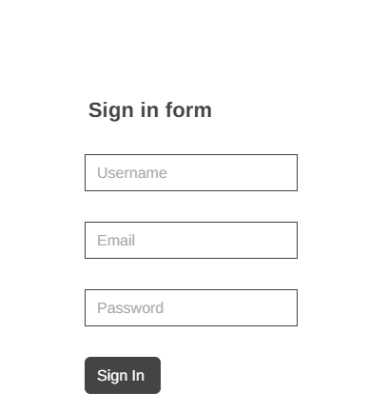
Fig 2.2.6 Sign in Form [4]

2.3 User Flow
The user flow diagram represents how the users navigate through different pages of the website, ensuring smooth interaction and accessibility from home page to other pages.

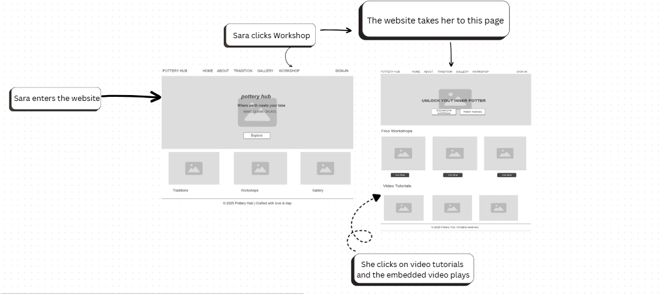
Fig 2.3.1 Sign in Form [4]
2.4 Mock-ups
The mock-ups display the visual design of each page, highlighting colours, typography, and interface elements to provide a realistic preview of the final website appearance.
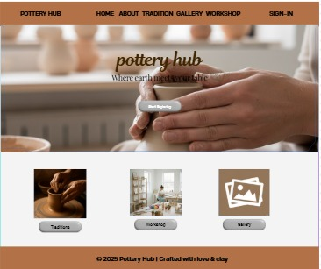
Fig 2.4.1 Home page [5]
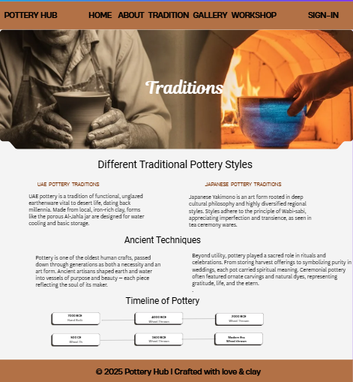
Fig 2.4.2 Traditions page [5]

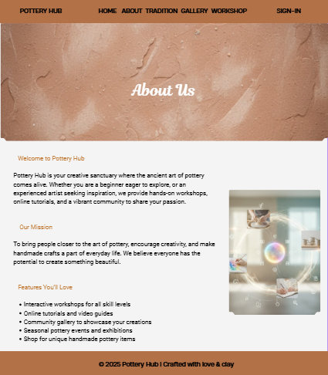
Fig 2.4.3 About page [5]
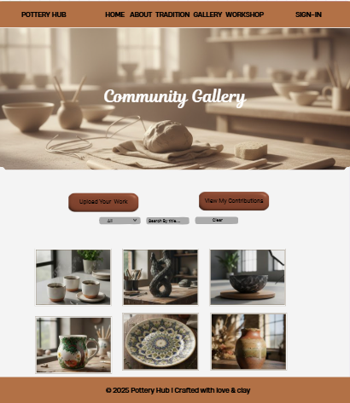
Fig 2.4.4 Gallery page [5]

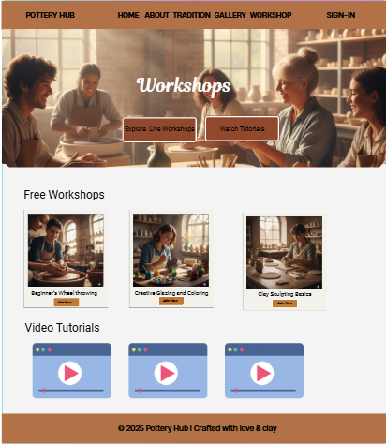
Fig 2.4.5 Workshop page [5]
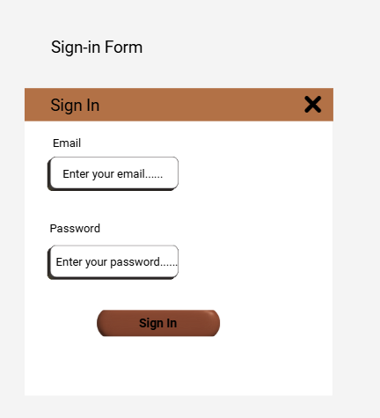
Fig 2.4.6 Sign in Form [5]

2.5 Heuristic Principles
Visibility of System Status: Pottery hub website maintains visibility of system status through clear navigation and readable texts. For example, if the user hover over a button or click it, the interface responds visually, letting users know that their actions are being registered. This helps users to understand where are they are within the website and what actions are happening.
Match Between System and the Real World: The contents and visuals of this website is connected to real-world concept of pottery – using earthy tones, images of pottery, video tutorials and pottery traditions. The words used in this site (like Home, About, Gallery, etc) are familiar to the users, helping them to connect quickly.
User Control and Freedom: Pottery Hub website allows full freedom for the users so that they can completely explore every section on their own, the Home page offers buttons like view our sections which can directly jump into the main sections of the site. This gives full control over their journey across the site.
Consistency and Standards: This site is consistent across all pages and it is clearly evident for the users. The site has same navigation bar on all pages, has used consistent colour palette throughout the site like black, brown and grey. This consistency helps users to interact with the site and maintains a professional look.
Aesthetic and Minimalist Design: The site carries an aesthetic look throughout the pages. The design focuses on simplicity and elegance, without unnecessary clutter of information. The use f minimal texts under images enhances the quality of the site and the use of readable large headings helps the users to easily go through the site.
Recognition Rather than Recall: This website helps users to recognize the options rather than recalling them as the site uses recognizable words such as “home”, “traditions”, “workshops” etc. They clearly indicate their purpose, so the users don’t need to recall what each label does. The visual images under sections also guide them initially
Help and Documentation: The “About” and “Workshop” pages act as informative sections, providing guidance on the purpose of the site and details about pottery-making. These sections help users understand the cultural background and educational intent of the site which functions as the in-built documentation for users within the site.

3. Usability testing and Evaluation

Usability testing is essential to make sure that the design meets actual user expectations. It enables the designer to verify assumptions, spot navigational issues, and make sure the interface conveys information clearly.
The evaluation plan for Pottery Hub focuses on testing usability of the site, clarity of the texts, and the visual representations. The testing will take place within the CSCU9X5 lab sessions, involving classmates as users.
The main testing objective is to determine whether the users can smoothy navigate across all pages, whether the interactive elements such as buttons, links, and the sign-in form function correctly. Specific tasks include checking that users can access each page easily, upload their works in the community gallery, and register for upcoming workshops. The evaluation will measure how well these functions operate and whether all the hyperlinks and interactive buttons responds.
If the users find difficulties with navigation or interaction, design improvements include adjusting colors, refining font readability and simplifying filters. To improve the user experience in future, audio descriptions could be added.
Although testing will be limited to lab sessions, the structured evaluation during tutorials will provide sufficient insight into design’s efficiency, usability and overall user experience. The feedbacks gathered from these sessions will be used to guide future refinements.

3.1 User Feedback

Test Area | Example User Comment | Suggested Improvement
Navigation | “Every page was easily able to locate” | No change
Sign-In Form | “The form loads correctly but needs clearer field labels” | Add placeholder text and improve alignment
Gallery Upload | “Easy to upload, the image preview is small” | Increase preview size for better visibility
Workshop Registration | “The button works but could be more noticeable” | Change button color to a brighter tone

4. Group Activities and Co-Design
During the Lab sessions and tutorials, group discussions played an important role in refining the concept and layout of the Pottery Hub website. Initial feedback from peers suggested that the color palette should reflect pottery-inspired earthy tones to create a more authentic atmosphere. Team members also proposed adding a page devoted to user interaction, which led to the creation of the Gallery page as a shared space for visitors to explore and engage with pottery artworks.
This collaboration during the group discussions really helped me to change my perspective about user experiences and accessibility. The discussions specifically urged me to pay closer attention to visual balance, readability, and color harmony. Such feedback directly influenced my final design decisions on using warm yet consistent background shades, maintaining navigation bars and button placements consistent, and including multimedia elements to increase visual appeal and user interaction.

5. Prototype and Resources Description
The prototype version of Pottery Hub includes a Home page and 4 other interconnected pages displaying key functionalities of the website. The prototype highlights the visual representation, navigation flow and interactivity. The prototype includes multimedia contents as images and videos, responsive grids, and hover animation. The current version is just a prototype that does not include all the information about pottery.
This prototype serves as a working model that represents the intended design and interaction of the final website. It demonstrates how users can explore cultural information, view gallery images, and register for the upcoming free workshops. The current version does not include every planned content section, but it clearly establishes the websites’ structure, interface consistency, and interactive flow.
External resources such as W3.CSS, and Google Fonts were used to achieve a responsive layout. JavaScript was added to implement interactivity for galleries. AI generated contents such as descriptive texts and images was used for visual support, which is clearly acknowledged in AI statement coversheet.
The prototype works as a very good basis for usability testing and further development, which can easily be turned into a fully functional website with added pages, multimedia and user-driven elements such as personalized recommendations.

5.1 File Description
FILE NAME | DESCRIPTION
home.html | This file includes all the main links to the other pages, theme of the website and a section as sign in form which is common for every page
about.html | This file includes detailed information of the site, its mission and features and sign in form
traditions.html | This file includes the traditional patterns of pottery making in UAE and Japan, Ancient techniques of pottery making, timeline of pottery across different eras, and sign in form.
gallery.html | This file includes gallery section with images. It also includes an upload button to upload user’s works, a filter button to filter the images, search button to search by title, a clear button to show all images and sign in form
workshop.html | This file includes upcoming workshops and their registration form, video tutorials, and sign in form
style.css | This file includes all the styles for the pages. This page defines the layout of the entire website
script.js | This file includes script for sign in form, gallery filter option and registration for online workshops
Images Folder | This folder contains all the images used for the prototype
W3.css | This file contains predefined CSS classes and rules to style the website. It is linked to html pages to make the design responsive, visually consistent, and easy to maintain. Using W3.css , it allows the website to incorporate features like grids, containers, buttons, and typography without writing all custom CSS from scratch

In conclusion, Pottery Hub demonstrates how interactive and easily accessible web technology can be used to preserve and promote traditional crafts through digital design. The prototype exhibits a balance between creativity and education by fusing contemporary UX principles with cultural storytelling. In addition to improving my technical proficiency, the design process helped me better grasps how well-considered interaction design can promote education and community involvement.

References:
- Template, https://www.w3schools.com/w3css/tryw3css_templates_architect.htm
- W3.css link, https://www.w3schools.com/w3css/5/w3.css
- Google Fonts, https://fonts.googleapis.com/css2?family=Dancing+Script&display=swap
- Wireframe, https://wireframe.cc/pro/
- Canva, https://www.canva.com/templates
- Google Gemini, https://gemini.google.com/app
- Chat GPT, https://chatgpt.com/
- University of Stirling Portal CSCU9X5 Module, https://canvas.stir.ac.uk/courses/18097/pages/week-6-ui-ux-design-2025

